**Practical No : 2**

**Aim** : Installation and Configuration of Virtualization using KVM.

Theory :

* KVM (for Kernel-based Virtual Machine) is a full virtualization solution for Linux on x86 hardware containing virtualization extensions (Intel VT or AMD-V). It consists of a loadable kernel module,.
* kvm. that provides the core virtualization infrastructure and a processor specific module, kvm-intel. or kvm-amd.
* Using KVM, one can run multiple virtual machines running unmodified Linux or Windows images. Each virtual machine has private virtualized hardware: a network card, disk, graphics adapter, etc.
* KVM is open source software. The kernel component of KVM is included in mainline Linux, as of 2.6.20. The user space component of KVM is included in mainline QEMU, as of 1.3.

Prerequisite: 1.Virtual Box/Virtual Machine

2. Ubuntu iso file

Steps: Installation of Ubuntu Virtual Box

Step 1:Start the virtualBox and Click on New

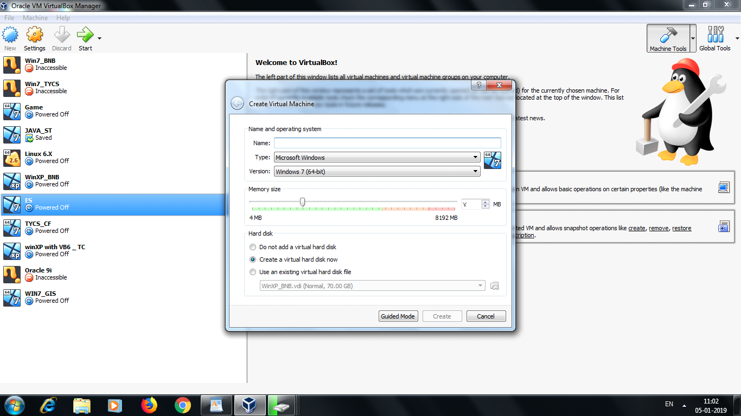

Step 2: Now Give the name as Cloud_Computing

Select type Linux

Version Ubuntu(32bit)/Ubuntu64(bit)

And Select Virtual HardDisk

And Click on Create button

Step 3: Now start the Virual Machine and Select the Ubuntu iso file and click on start

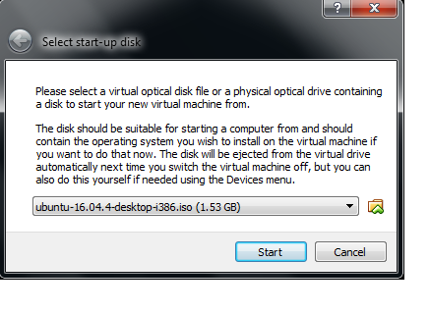

Now see the below ScreenShots for installation

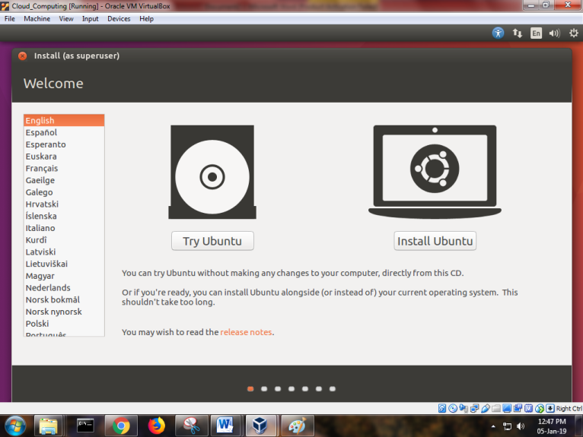

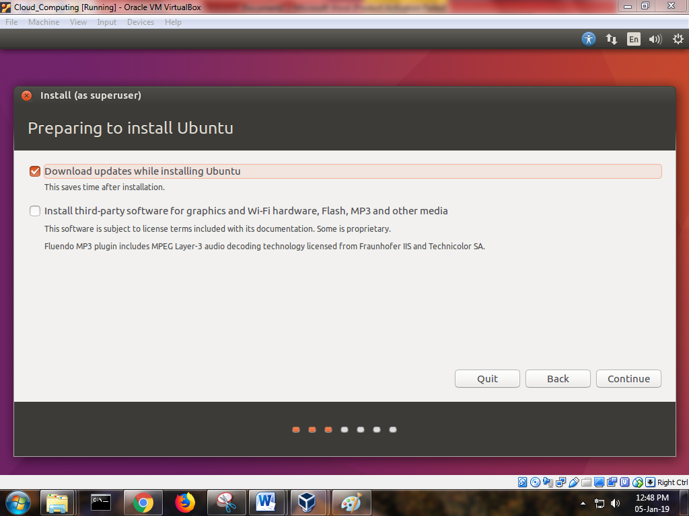

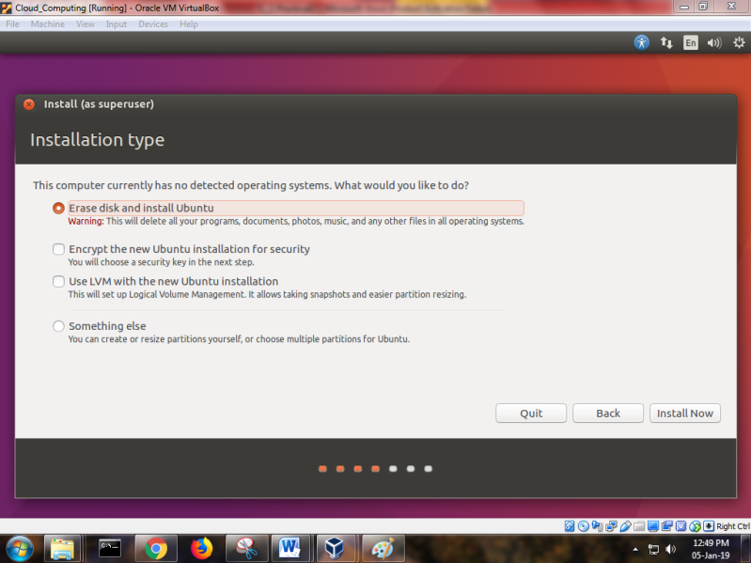

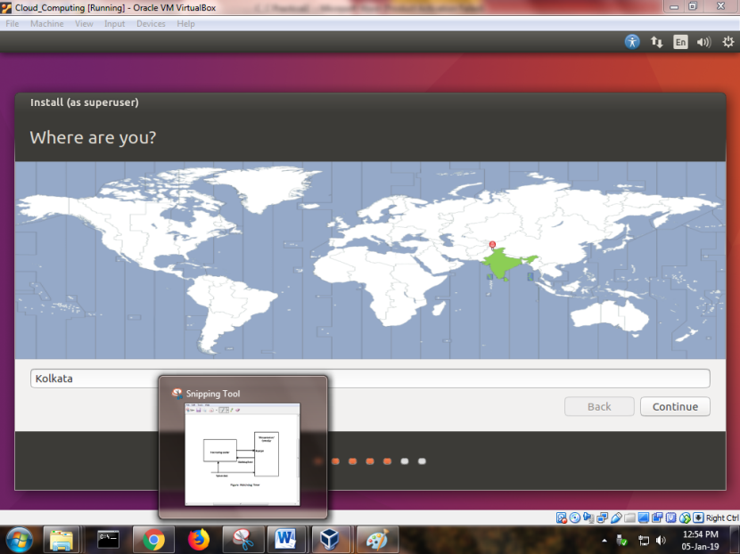

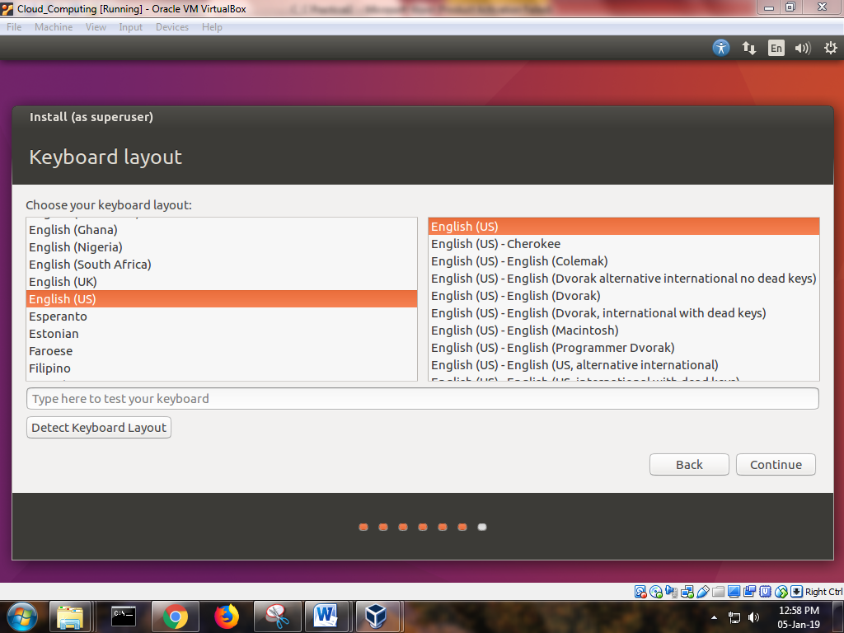

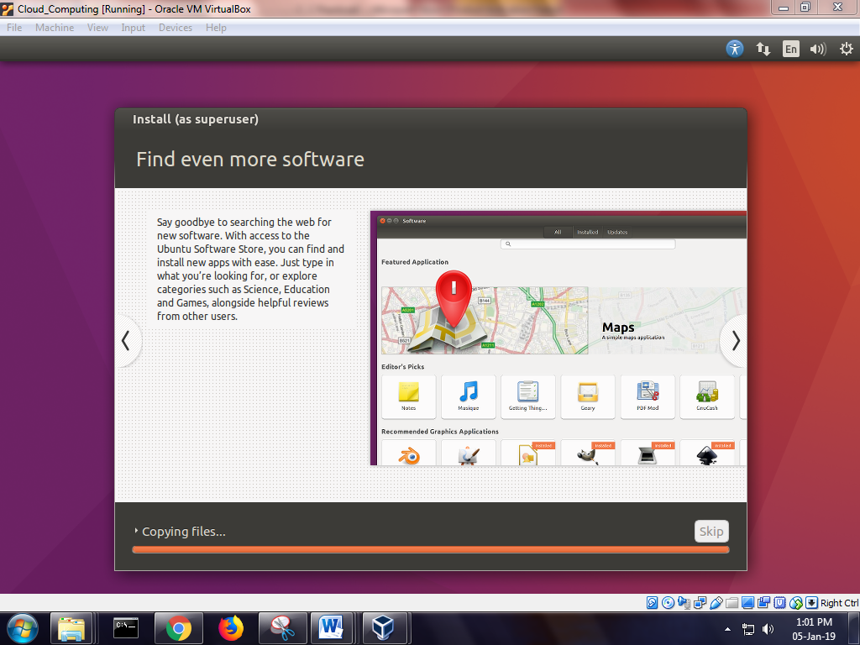

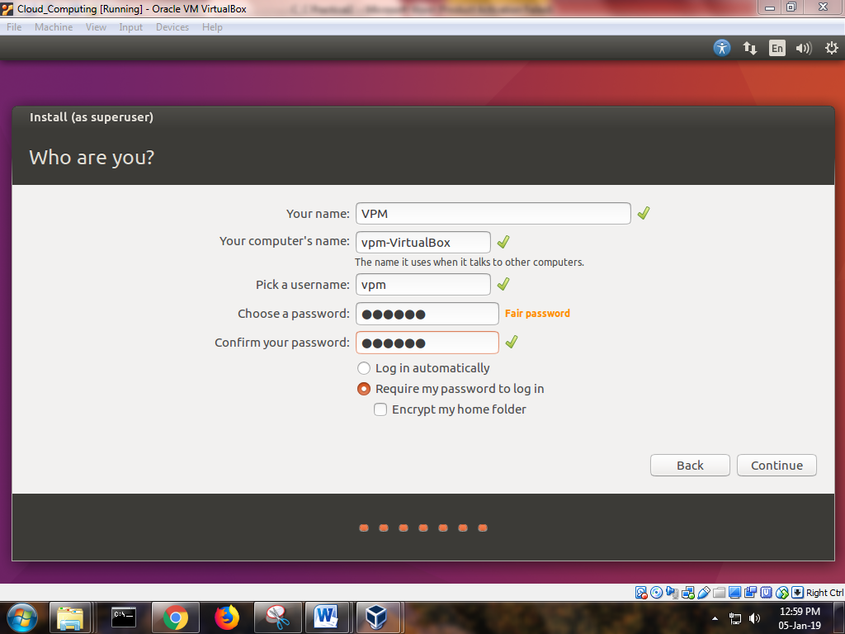

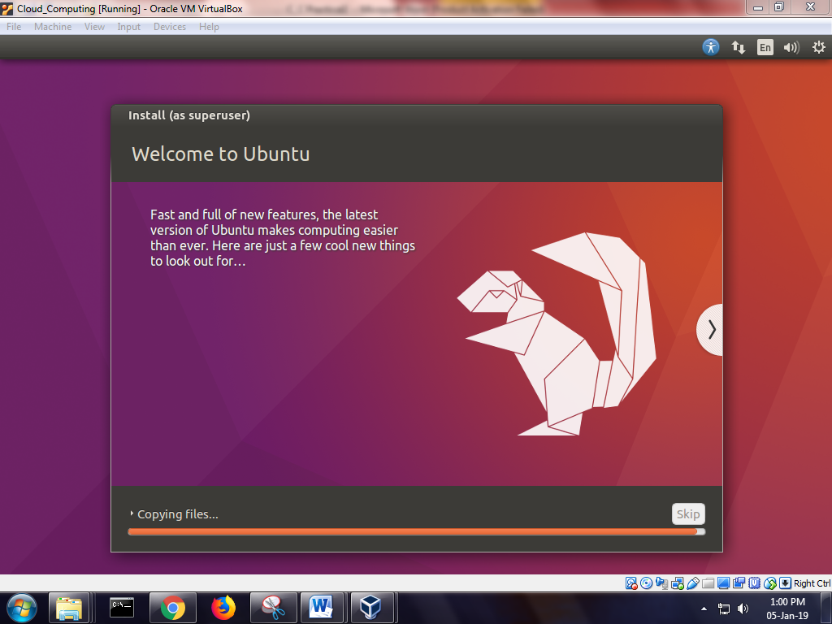

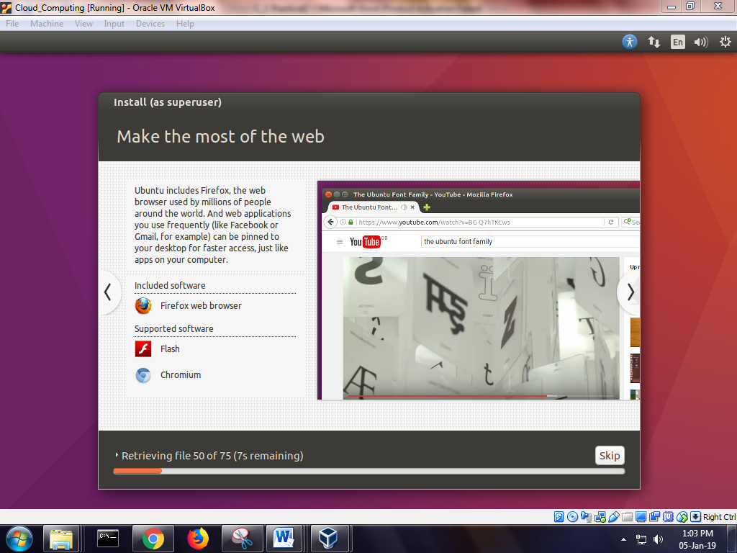

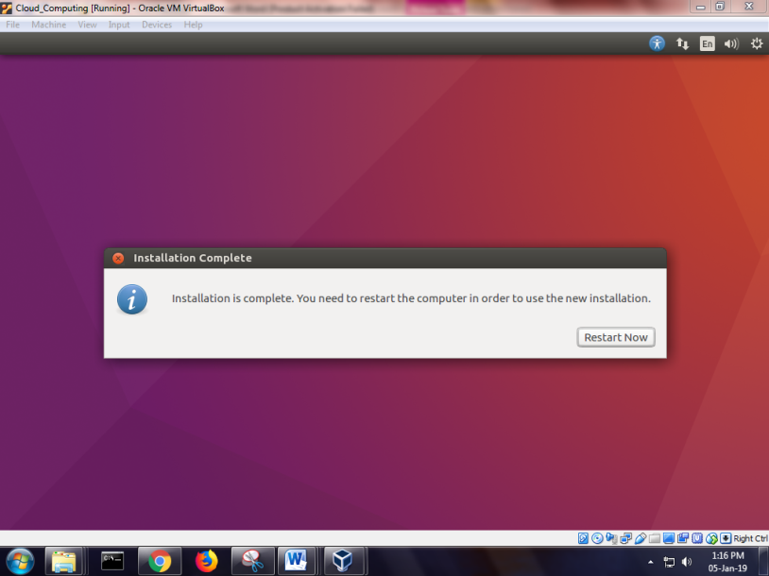

Step4 : Now open the terminal and perform the following command

sudogrep -c "svm\|vmx" /proc/cpuinfo

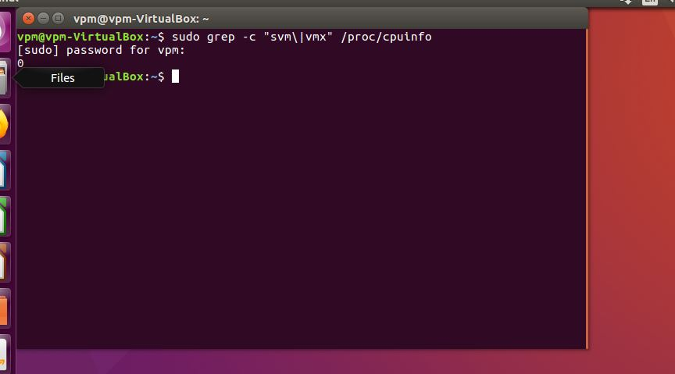

sudo apt-get install qemu-kvmlibvirt-bin bridge-utilsvirt-manager

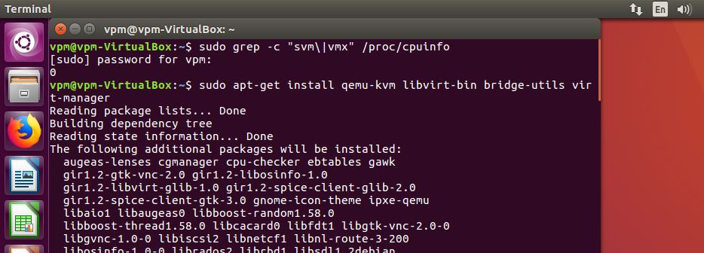

Sudo adduser shraddha

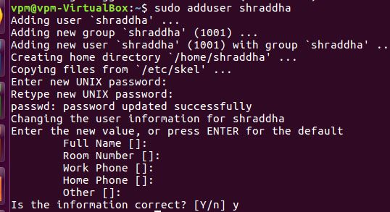

Sudo adduser shraddha libvirtd

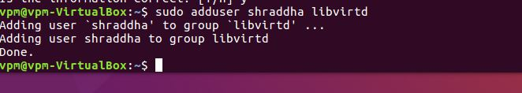

virsh -c qemu:///system list

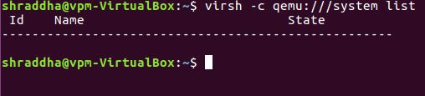

Virt-manager

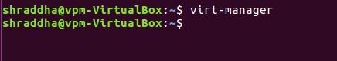

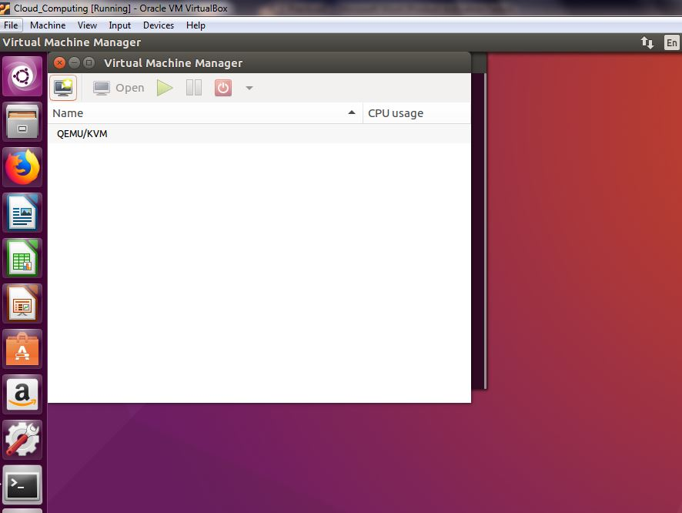

Click on new virtual machine in qemu and perform the following step

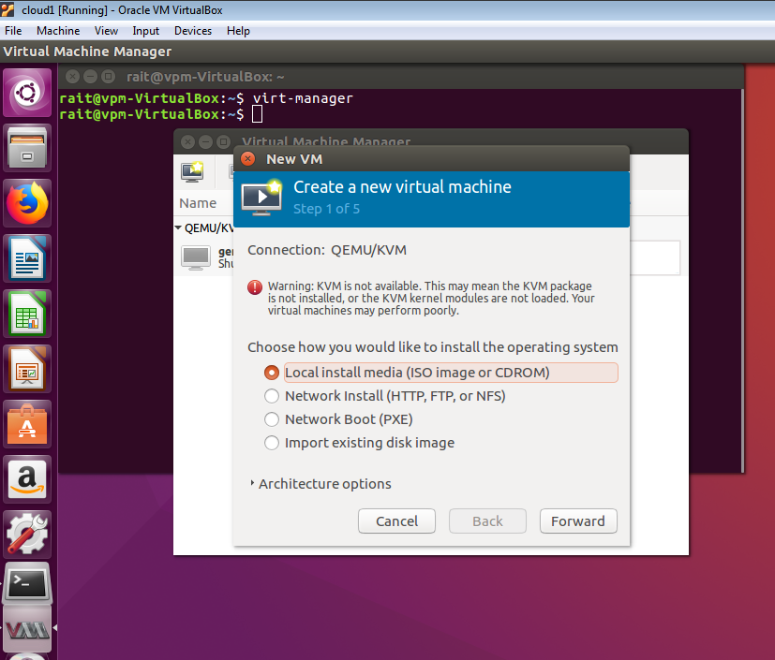

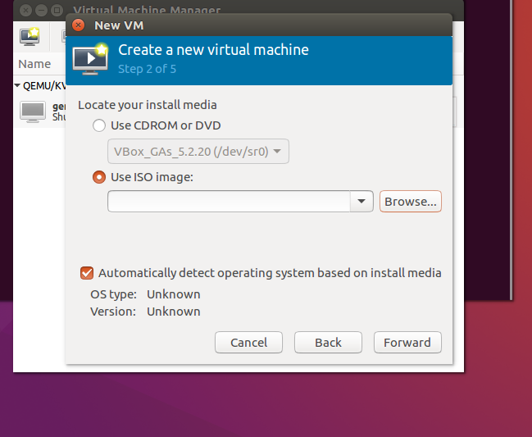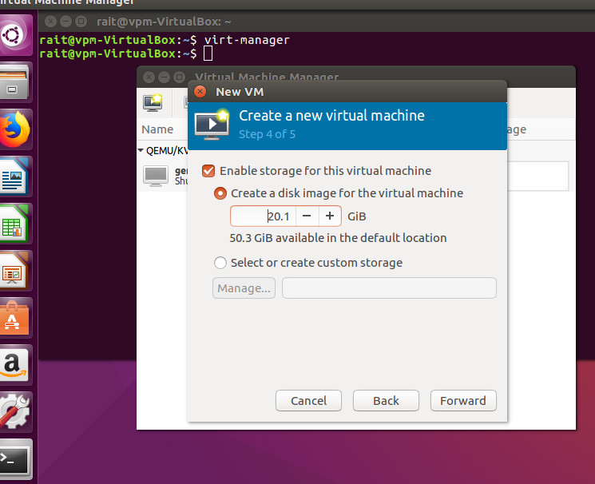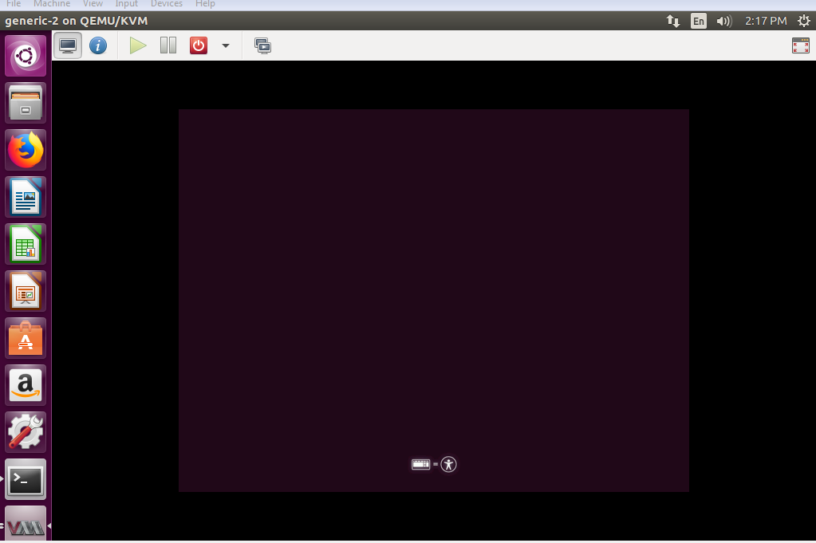

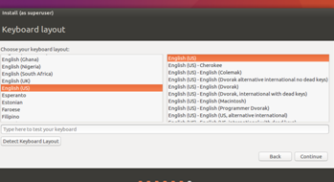

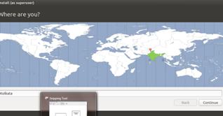

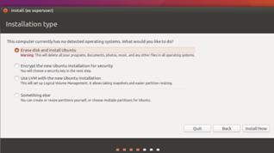

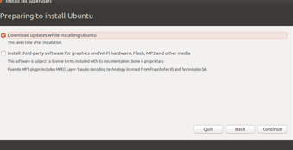

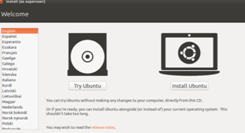

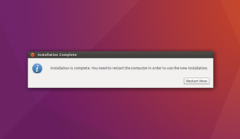

After that you will get final output

